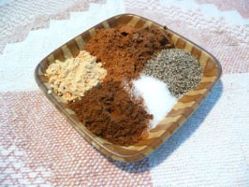
Portland's Hillvilla Restaurant Pumpkin Pie
Ingredients: For the pie
- 2 large eggs (room temperature)
- 1 teaspoon vanilla
- 1 (16 ounce) can pumpkin
- 1/4 cup firmly packed brown sugar
- 2 1/2 teaspoons pumpkin pie spice (using Special Pumpkin Pie Seasoning recipe below)
- 1 cup evaporated milk
- 1/2 cup half-and-half
- 1/2 cup granulated sugar
- 9 inches pastry shells

Directions: For the pie:
  - Mix together eggs, vanilla, pumpkin, brown sugar and seasoning mix.
  - In saucepan, mix evaporated milk, half and half, and granulated sugar. Cook over low heat until sugar dissolves.
  - Add to the pumpkin mixture.
  - Pour into unbaked pie shell and bake at 425°F for 15 minutes.
  - Lower heat to 350°F and cook 40-50 minutes until done, when a knife comes out clean.
  - Store in refrigerator.
- For the seasoning: Combine all ingredients. Store in airtight container for use in other baking. Makes about 3/4 cup.
Special Pumpkin Pie Seasoning for Hillvilla Pumpkin Pie:

4 tablespoons ground cinnamon
2 tablespoons ground allspice
2 tablespoons ground black pepper (that's correct!)
2 tablespoons salt
1 tablespoon ground nutmeg
1 tablespoon ground cloves
1 tablespoon ground ginger
Mix all ingredients together, and store in an airtight container. Makes approximately 3/4 cup

